**Optimising trigger times for social distancing measures (SDMs)**

M. Woolhouse and B. van Bunnik, University of Edinburgh (04/03/20)

Key conclusions

* Optimal trigger point differs for different SDM stratgies: a ramping up strategy should start earlier than a constant strategy.
* Optimal trigger point differs for different durations/intensities: a short, sharp shock should start later than a gentler but prolonged intervention.

Policy Implications

* If SDMs are to be introduced gradually then the first SDMs should be introduced substantially (weeks) earlier than if all SDMs were imposed at the same time.
* If more intense SDMs are to be introduced (but for a shorter period) then they should be introduced later. Conversely, if less intense SDMs are to be introduced (but for a longer period) then they should be introduced earlier (possibly immediately).
* An accurate estimate of position on the epidemic curve is required. If this is not feasible (e.g. if it is believed that substantial fractions of infections are not being reported) then it will be important to explore the consequences of introducing SDMs earlier or later than optimal.

Results

The baseline scenario is as for our first report (29/02/20). This gives peak I(t)=0.153 on day 79 and total I=0.797.

Strategies are compared for optimal epidemic curves. Optimal is defined as the curve that gives the lowest value for the maximum proportion infected at any one time during the course of the epidemic. This is chosen for consistency with the policy objective of flattening the peak.

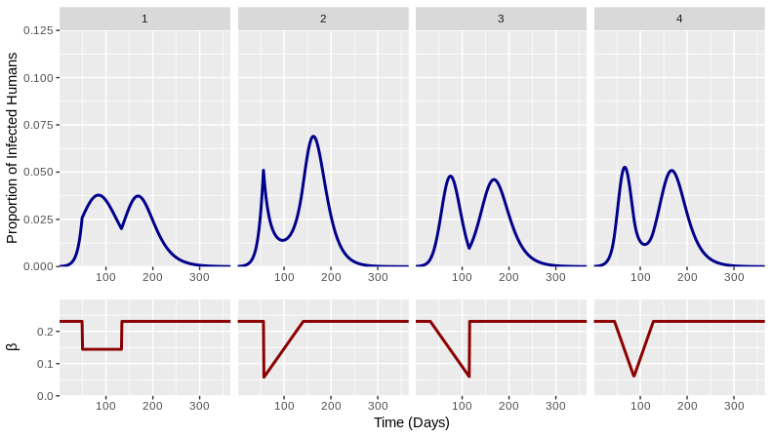

*Figure 1. Epidemic curves (blue),* β*(t) curves (red) and summary statistics for four time-varying, fixed-period SDM strategies. Each is optimised for trigger day.*

Figure 1 compares four different scenarios for the effects of SDMs implemented for a fixed 12 week period. The trigger day has been selected to give an optimal epidemic curve.

Optimal trigger days vary from 31 (Scenario 3) to 56 days (Scenario 2). The corresponding maximum height of the epidemic curve varies from 0.038 (Scenario 1) to 0.069 (Scenario 2).

The general pattern is that if SDMs are initially less intense then they should start earlier.

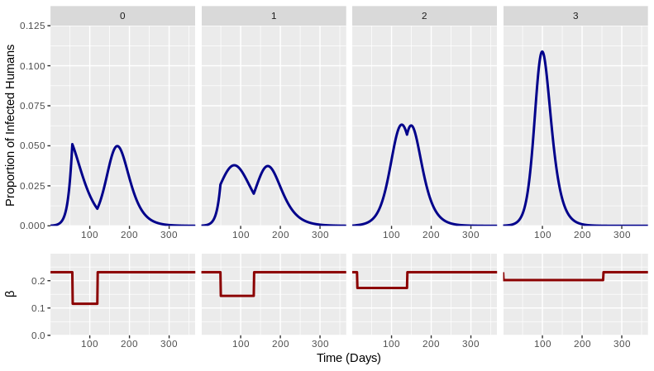

*Figure 2. Epidemic curves (blue),* β*(t) curves (red) and summary statistics for four variants of Scenario 1 (see text). Each is optimised to trigger point.*

Figure 2 compares the effects of four variants of Scenario 1. These maintain the same net reduction in β(t) but distributed over different fixed periods. For each the trigger point has been selected to give an optimal epidemic curve.

The optimal variant is the same combiation of parameters shown in Figure 1 (Scenario 1.1). This is intermediate between a short, sharp shock implemented later in the epidemic (Scenario 1.0) and low intensity interventions started early and maintained over a prolonged period (Scenarios 1.2 and 1.3).

The general pattern is that the shorter and more intense the SDMs then the later they should start.

Technical Details

SIR model implemented in R and C++ independently (code to be made available at https://github.com/bvbunnik/COVID-19.git).

Baseline parameter values: R0=2; β = 0.231; doubling time = 6 days; trigger point I(t)=0.01, giving 41 days as the start time of the intervention; SDM duration = 12 weeks.

SDMs are assumed to have an impact on β but vary as to how that reduction is distributed over time (Figures, red curves). For Figure 1 the mean reduction in β = 37.5%. For Figure 2 the mean reductions are 50%, 37.5%, 25% and 12.5% for Scenarios 2.0, 2.1, 2.2 and 2.3 respectively.

Rationale

SDMs are intended to be time limited. Multiple SDMs are available and can be implemented independently. (Many) SDMs are hugely socially and economically costly.

We have very little knowledge of the likely effect of a given SDM (or combination) on β.

Here, we assume only that costs and effects can be ‘exchanged’ so that by implementing different SDMs at different times we can alter the shape of the β(t)-curve during the period of interest.

We can do this for a very wide range of mean reductions in β in order to ask whether the comparisons between scenarios (different β(t) curves) are consistent and, if not, what influences this.

Caveats

This is a very simple model and is intended to be illustrative, not predictive of an actual COVID-19 epidemic.

We do not take into account time varying compliance with imposed SDMs.

We do not take into account social distancing arising from spontaneous behavioural change and affecting β.

Ongoing work

We still need to optimise combinations of trigger point and duration.

We need to explore the effects of uncertainty around position on the epidemic curve. One specific question is whether starting too early or starting too late results in the largest deviations from the optimal outcome.

We need to explore the effects on uncertainty around reductions in β achievable using SDMs.